________________________________________________________________________________

Albany VFW Post 2785 Rider’s Group
315 Philema Road, Albany, GA. 31701

Membership Application
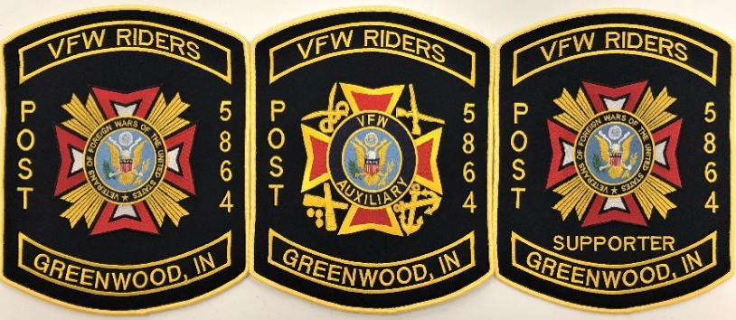

q Annual Dues - $25 q Life Member Dues - $150 or
q Life Member Installment Dues – 6 payments of $25
q Cash q Check -- q ____ Patches @ $100 each*

-- The Rider Group’s Annual Dues are payable by June 1 of each year.

-- The Life Member Installment Dues are payable each month no later than the
5th day of each month for 6 months.

Name _____________________________________________ Date _________________________

Address ___________________________________________ City / State ____________________

Phone ____________________ E-mail ________________________ Zip Code ________________

I hereby apply for membership as a q Post Rider Member
q Post Auxiliary Rider Member or a
q Post Supporter Rider Member

q I attest that by completing and signing this application that I am a citizen of the United States
and that I will follow the bylaws, and all other regulations of the Albany VFW Post 2785
Rider’s Group while I am a member of this organization.

______________________________________ __________________________
Applicant’s Signature Date

* The Application and pricing for the VFW Rider’s Patch was updated on May 20, 2025 . The Patch includes shipping.

